**120A3051**

**Shreya Idate**

**Batch: E3**

**Experiment No: 12**

**AIM**: Creating Docker Volumes

**THEORY:**

Docker also gives you the capability to create your own Docker images, and it can be done with the help of Docker Files. A Docker File is a simple text file with instructions on how to build your images.

**FROM** keyword tells Docker, from which base image you want to base your image from. In our example, we are creating an image from the Ubuntu image.

The next command is the person who is going to maintain this image. Here you specify the **MAINTAINER** keyword and just mention the email ID.

The **RUN** command is used to run instructions against the image. In our case, we first update our Ubuntu system and then install the nginx server on our Ubuntu image.

The last **CMD** command is used to display a message to the user.

**Docker Volume: Making data persistent across the containers and volume**

1. Create a volume, List a volume and inspect a volume

root@puppet-master:~# **docker volume create vol1**

vol1

root@puppet-master:~# **docker volume list**

DRIVER VOLUME NAME

local vol1

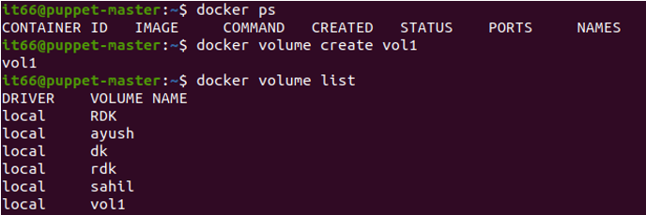

root@puppet-master:~# **docker volume inspect vol1**

[

{

"CreatedAt": "2022-06-29T22:57:27-07:00",

"Driver": "local",

"Labels": {},

"Mountpoint": "/var/lib/docker/volumes/vol1/_data",

"Name": "vol1",

"Options": {},

"Scope": "local"

}

]

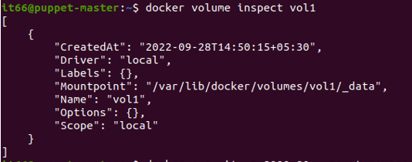

Check the existing content of a created volume:

root@puppet-master:~# **ls /var/lib/docker/volumes/vol1/_data**

1. Select an existing image and run it using --mount option to attach the target location of container to the source location of volume

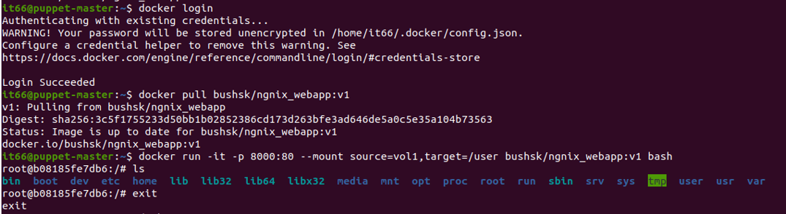

1. Check the existing content of a container in the target location and make few changes in the running container by adding a layer of nano and modifying the index.html as shown

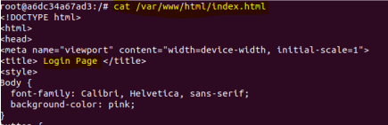

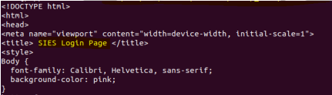

1. Now check the modified content visible in the source location of a volume:

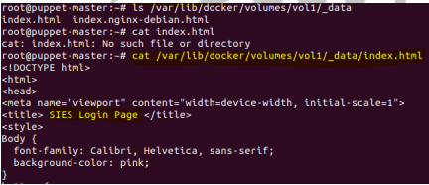

1. Similarly, modify the content in the source location of a volume:

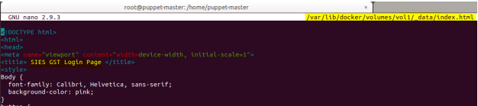

1. Now , run the container and check the modified content visible in the target location of a container:



1. Open a web browser and got locathost:8000 and verify the output:

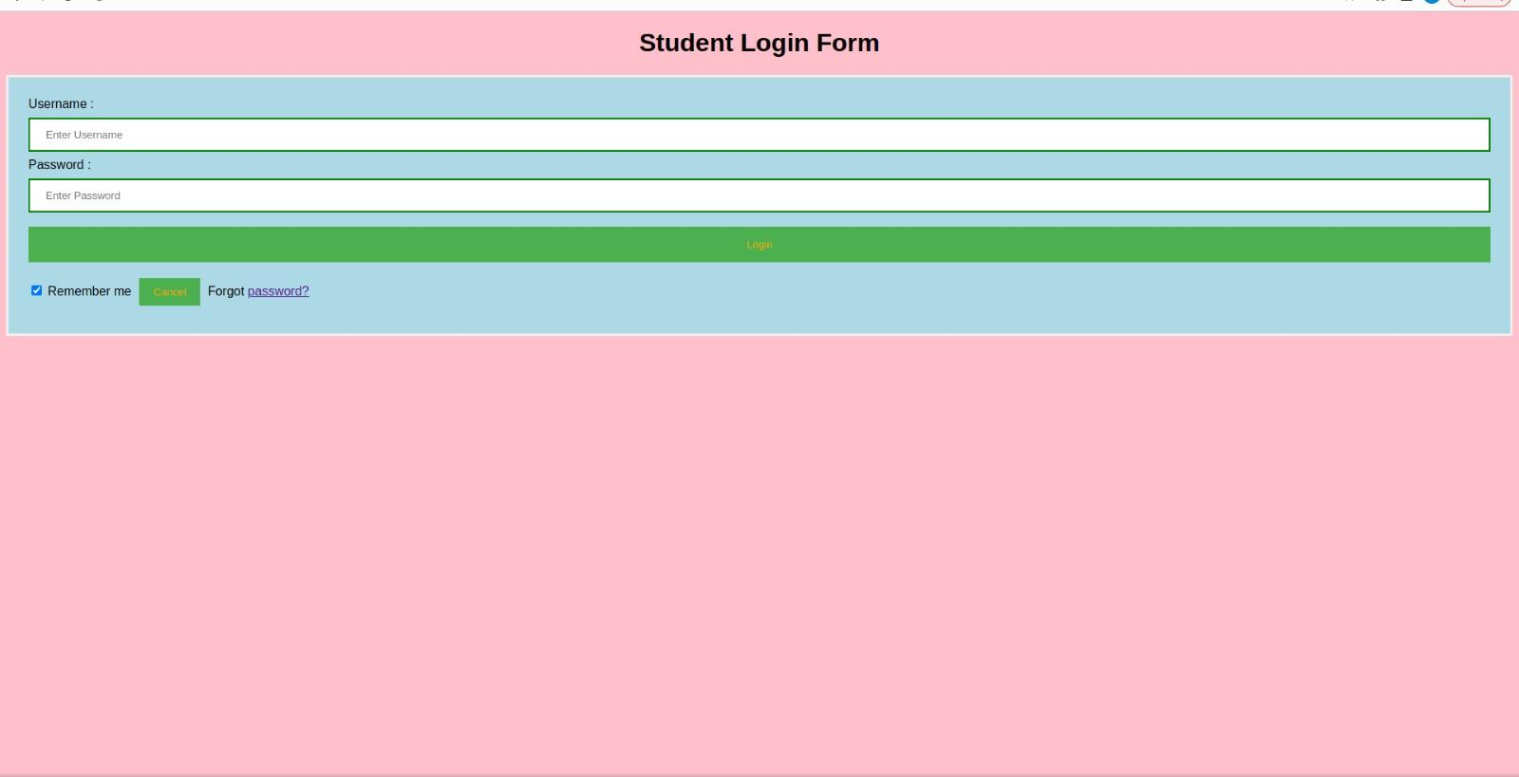

**Conclusion**: We are able to understand the concept of Docker volume and have successfully created it.